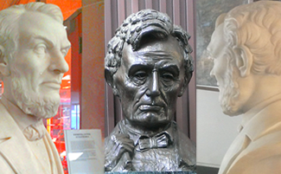

Standing Witness
A Symposium Celebrating Pioneers of Color in Santa Clara and the Bay Area
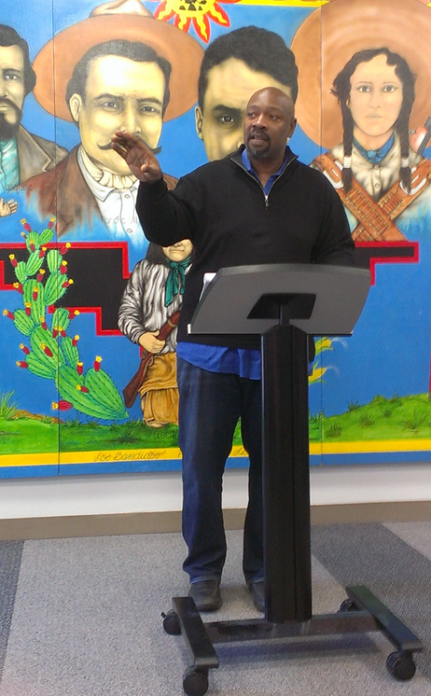
Commemorating the 150th Anniversary of the End of the Civil War and Abolishing Slavery
Saturday, April 18, 2015 1:30 – 5:30 pm
Theater, San Jose State University New Student Union
9th and San Fernando Streets
San Jose, CA 95112

Admission is Free – Students May Earn Extra Credit

Featuring:
  - Associate Professor Herbert Ruffin II, Syracuse University, Department of African American Studies and SJSU Alumnus. Author of “Uninvited Neighbors: African Americans in Silicon Valley 1769-1990”
  - Bonnie Montgomery, historian, Stanford Archeology Center 1886 Newspapers Project
The Plight of Chinese Laborers in San Jose in the late 1800s”
  - Jean Libby, community historian and author, Allies for Freedom
“Family and Friends of John Brown in Santa Clara County”
  - The Rev. Jerry Drino – Episcopal priest and coordinator of the Cassey Memorial Project, will present the work of California abolitionists Peter and Anna Cassey in the face of 2500 slaves in the 1850’s.
- Stan Yogi, ACLU, will present Timelines for Wherever There is A Fight, How Runaway Slaves, Suffragists,
Immigrants, Strikers and Poets Shaped Civil Liberties in California.
- Intro of The Devil in Silicon Valley: Race and Mexican Americans by Stephen J. Pitti
- Lovie Spencer, Jr. will facilitate a Truth Telling Roundtable Discussion led by SJSU Students/Millennials

Sponsored by

For more information: The Rev. Jerry Drino, jdrino@hopewithsouthsudan.org
Lovie Spencer, lovie@sonic.net; The Rev. Kathleen Crowe, chaplain@canterburybridge.org

